Buck Type Drivers: Part # U-6800-NSI

U-6800-NSI Buck driver boards are designed around the National Semiconductor LM3404HV regulators. U-Tron buck controller boards are designed to handle up to 3 circuits of maximum 10 high power LEDs each (total of 30 LEDs, U-6800-010 lamps and not suitable for the U-6800-014 LED lamp sets) This driver board can be configured to 1, 2 or 3 lamp sets. The LM3404 was chosen for this purpose and because the combination of high output current, high input voltage, and high duty cycle create the greatest demand for low junction to ambient thermal resistance (θJA).

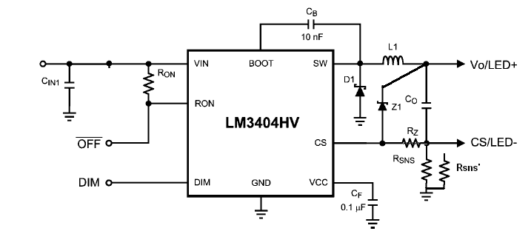
Figure 1
Buck Converter Current Loops

Theory of Operation

U-6800-NSI are buck regulators with a wide input voltage range, low voltage reference, and a fast output enable/disable function. These features combine to make them ideal for use as a constant current source for LEDs with forward currents as high as 1.2A. (Note for U-Tron Lamps the current is set at 320 mA) The controlled on-time (COT) architecture is a combination of hysteretic mode control and a one-shot on-timer that varies inversely with input voltage. Hysteretic operation eliminates the need for small signal control loop compensation. When the converter runs in continuous conduction mode (CCM) the controlled on-time maintains a constant switching frequency over the range of input voltage. Fast transient response, PWM dimming, a low power shutdown mode, and simple output over voltage protection round out the functions of the LM3404HV.

Figure 2
, Buck Converter Current Loops

Buck Type Drivers Features

- Integrated 1.0A MOSFET
- VIN Range 6V to 42V (LM3404)
- VIN Range 6V to 75V (LM3404HV)
- 1.2A Output Current Over Temperature (designed for 330mA)
- Cycle-by-Cycle Current Limit
- No Control Loop Compensation Required
- Separate PWM Dimming and Low Power Shutdown.
- Supports all-ceramic output capacitors and capacitor-less outputs
- Thermal shutdown protection
- Package - PSOP-8
- Special Application guaranteed by Manufacture for 1.0A Constant Current Buck Regulator for Driving High Power LEDs

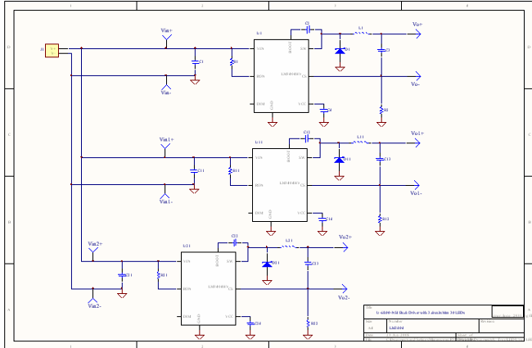

Figure 3
U-Tron Buck Driver Board
Circuit Diagram

Remote LED Arrays

In our LED Street Lamps LED array are separated from the Driver boards (several inches or more). In consideration of this situating the output capacitor C3, C13 and C23 are rated for AC impedance 100V is used to withstand the LED array parasitic inductance from the rest of the converter. The current sense resistor R1, R12 and R22 shall remain on the same PCB, close to the LM3404HV.

